Using RosettaTablet

1. Turn on the computer.
2. Log into *fvalc* *fvalc*. Hit ***return*** on the keyboard.

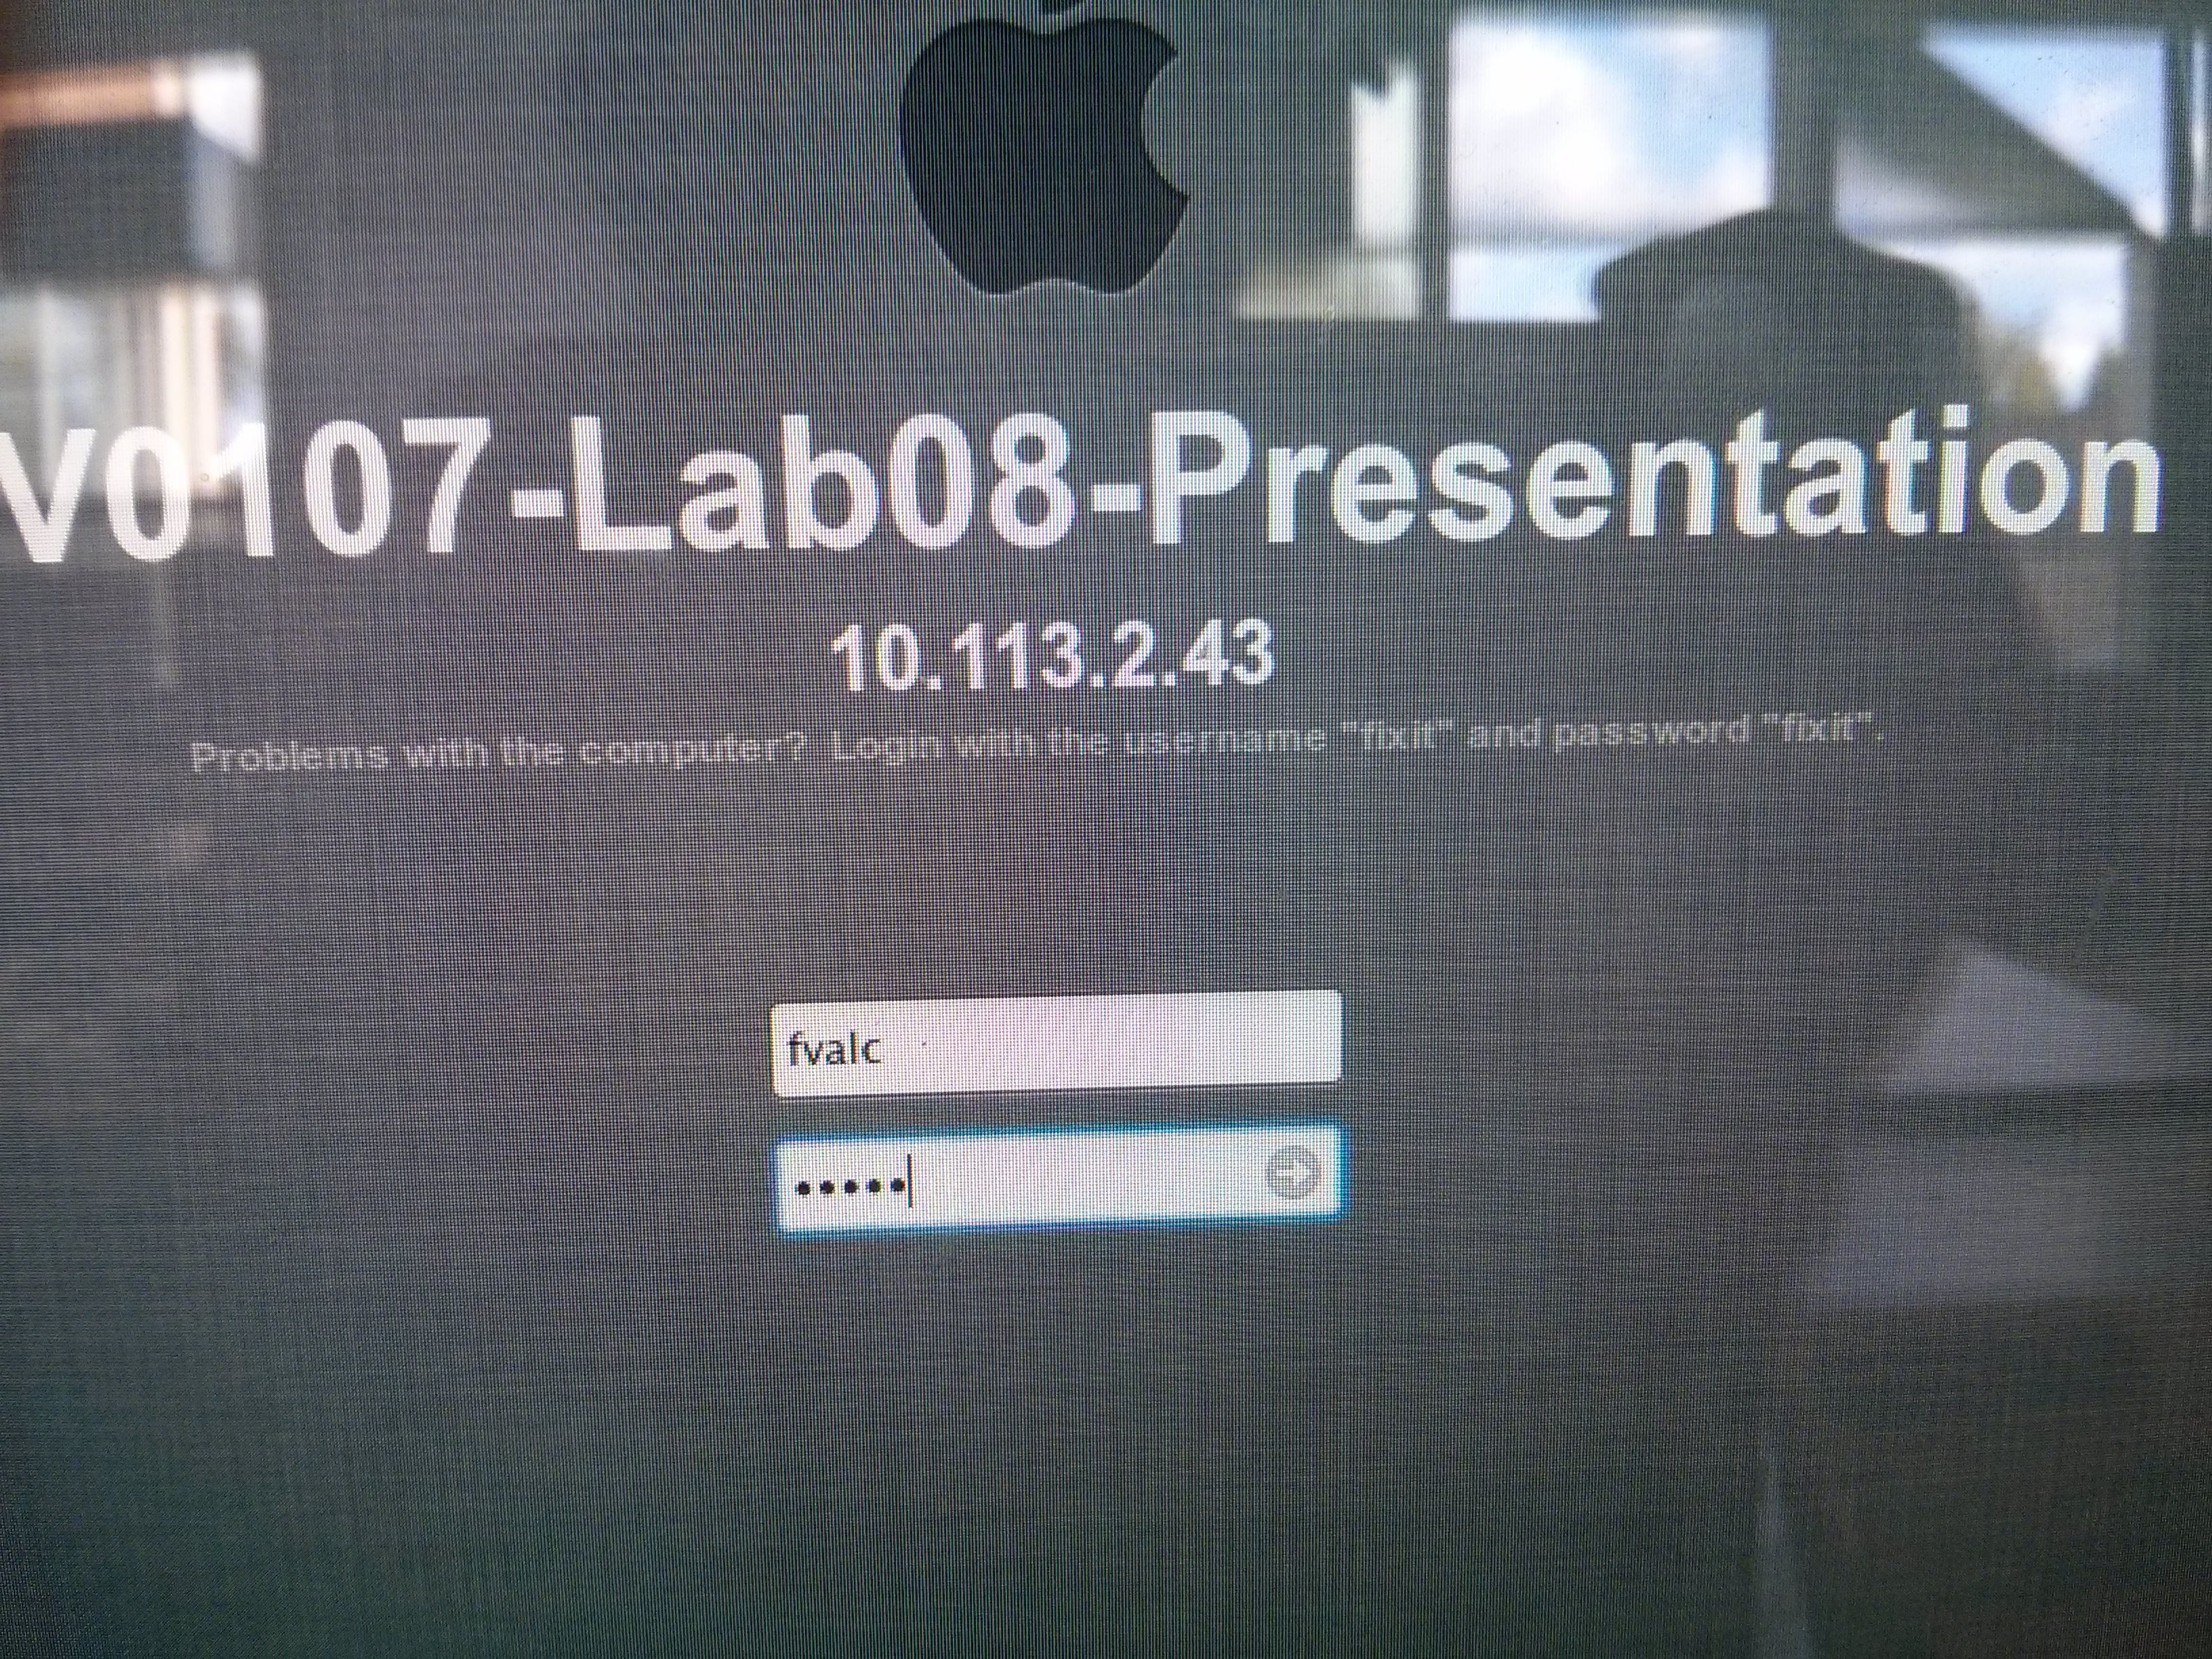

3. Click on the **RosettaTablet** icon (1 left click).

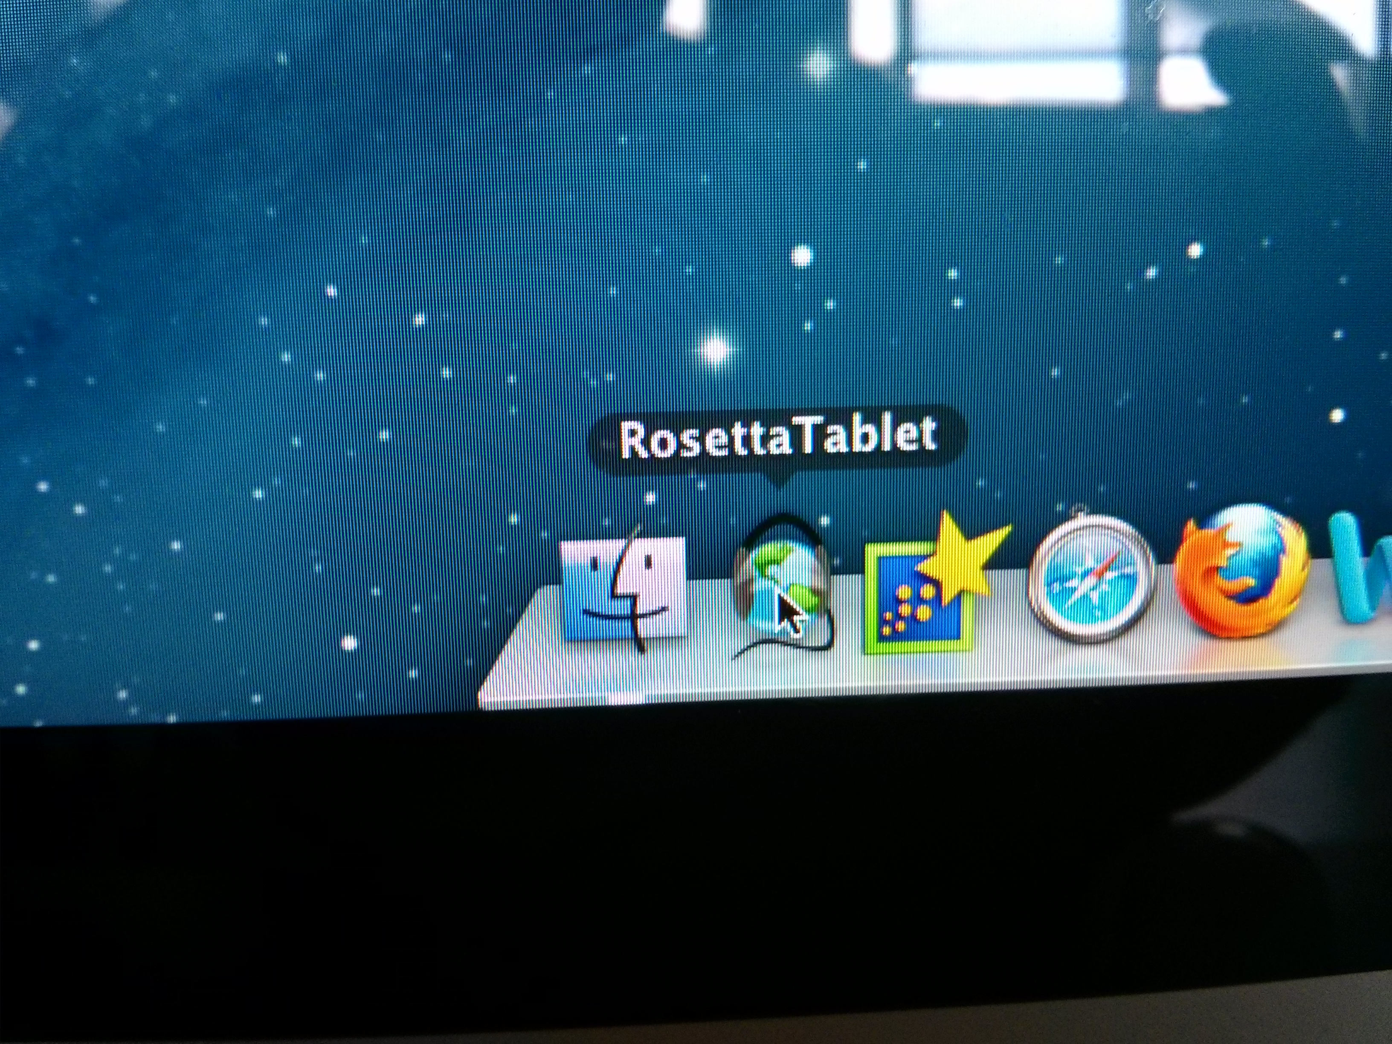

1. Students can choose a **Unit** > **Lesson** > **Listen** or **Say**.

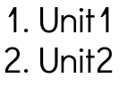 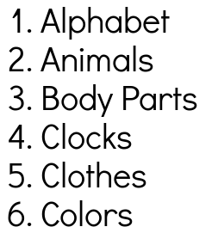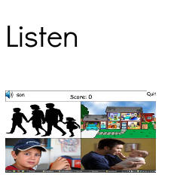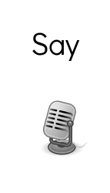

4a. **Listen**: Students can click on the 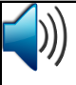icon to hear the word repeated. Students then click on the picture matching the word shown at the top.

A student’s percentage score is shown at the end.

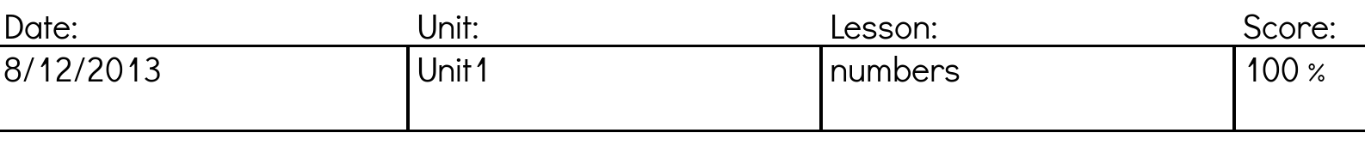

4b. **Say**: Students can click on the icon to hear the word repeated. Students click on  to record their own voice (talking to the camera at the top of the screen). After 5 seconds, the computer pronunciation and the student’s voice are played side by side. Click **Next** to go to the next word. Students are returned to the main menu after the last word in a lesson.